**Interview setup:**

We will ask the interviewee a couple questions about his background and then have him go through our prototype and finish a small project as a user of the software. After that we will discuss his experience of the software and what he would do better.

Basic info questions:

1. What is your name?
2. How old are you?
3. What is your education?
4. Have you worked at a car rental or a similar place?
5. What is your current job?

Project for the interviewee:

You will be a user of a software and the questioner will be a customer that wants to rent a car.

The customer is a new customer that wants to rent a van (Iveco Daily) and be the only driver. He wants the insurance package nr. 1 and to pay with cash.

Time period of rental: 22/04/2019 – 29/04/2019

Epilogue:

1. Was there anything that you thought was unclear about this software’s functionality?
2. Is there anything that you would change?
3. Do you have a good name for the software?

**Interview 1:**

Basic info:

1. Rökkvi Steinn Finnsson
2. 21-year-old.
3. Finished upper secondary school, now a student at Reykjavík University.
4. Has worked at a car rental (AVIS).
5. Not working, student.

Adjustments on prototype:

1. Change tablet of car info.
2. Auto create new customer if customer is not registered.
3. Make names of insurance packages clearer.
4. Make a possibility to edit order afterwards rather than accept everything twice.
5. More information on order confirmation, especially regarding insurance packages and what they include.
6. Combine the order overview and order confirmation, don’t print out similar things like that twice. Rather make one more detailed order confirmation.
7. On order confirmation, add price per day for rental and insurance.
8. Add driver’s license ID, and the availability to register a credit card to the customer.

Epilogue:

1. Nothing unclear, easy to use.
2. See adjustments on prototype.
3. No name idea.

**Examples of changes made with consideration to Rökkvi’s comments:**

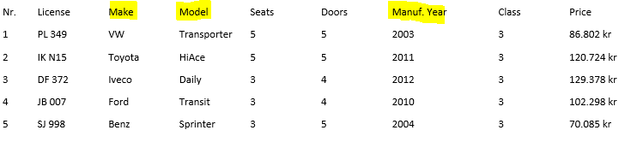

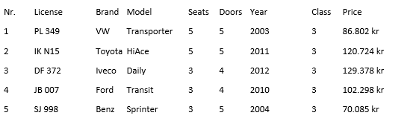

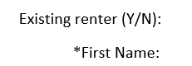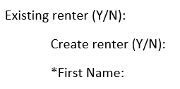

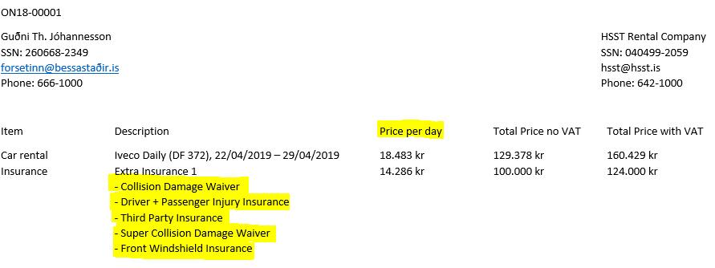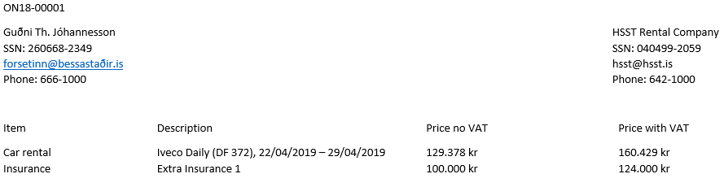

**Interview 2:**

Basic info:

1. Arndís Þóra Þórisdóttir
2. 20-year-old.
3. Finished upper secondary school, now a student at Reykjavík University.
4. Hasn’t worked at a car rental or similar workplace.
5. Basketball coach for Breiðablik.

Adjustments on prototype:

1. Make clearer where you’re typing in on home screen.
2. Change existing renter to existing customer, not clear what renter is.
3. Be more clear what fields are required in creating a customer.
4. Insurance tablets complicated.
5. Payment method needs a point of input.

Epilogue:

1. Mainly just insurance tablets.
2. See adjustments on prototype.
3. No name idea.

**Examples of changes made with consideration to Arndís’s comments:**

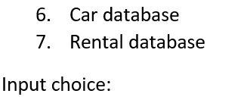 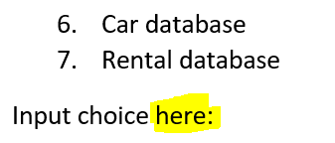

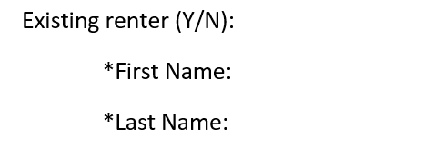 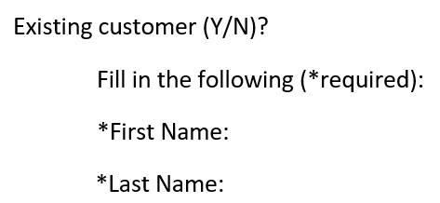

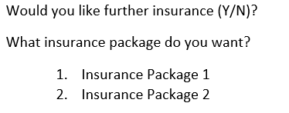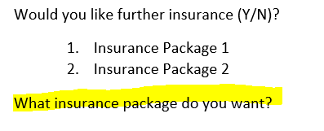

**Interview 3:**

Basic info:

1. Magnús Ingi Gylfason
2. 20-year-old.
3. Finished upper secondary school.
4. Hasn’t worked at a car rental.
5. Works at the Toyota agency in Iceland as a car salesman.

Adjustments on prototype:

1. Insurance tablets to complicated, make more user friendly.

Epilogue:

1. Mainly just insurance tablets, again.
2. See adjustments on prototype.
3. No name idea.

No major changes were made after this interview.

**Interviews epilogue:**

After taking 3 interviews we have made some changes to our prototype. The only thing we have not changed so far is the insurance tablets. We will make further changes to them later in the process we do not think that is important at this point, because for now we are only thinking about easy access and the software’s functionality.  
With this requirement analysis report there will be two attachment with the prototype before interview and after all interviews.